This is an example only. DELETE THIS BOX BEFORE PRINTING THIS DOCUMENT.
You can add your Clinical Service logo, contact details and photos/artwork to this document.
Download a copy of this Word document template from www.caringathomeproject.com.au



Helping to manage symptoms
at home

.
V2 January 2023




If you want to care for your loved one at home or on Country, you can help manage symptoms like pain or feeling sick in the gut.

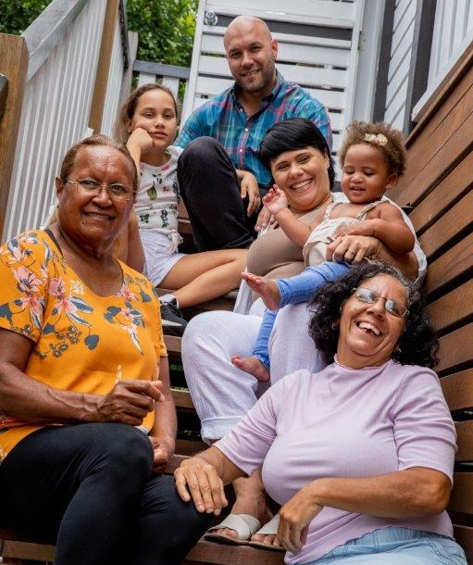
- Your nurse will teach you what you can do to help.
- Sometimes medicine may be needed to help your loved one feel comfortable.
- If your loved one cannot swallow, you can give medicine under the skin.
- Your nurse can show you how to give the right medicine at the right time under the skin.
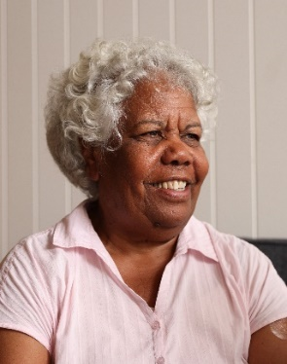

“Looking after my husband was, it was a cultural thing of course. We always look after our elders and the sickly and try to keep them at home as long as possible.
So, when he was diagnosed and told that he would not get better, it was just a no brainer he was coming back home to be surrounded by family.
All of the family got to see him all the time and he loved it and they did too. It wasn’t like going into a hospital or you know a palliative care unit. It was all in the home. I mean we had BBQs.
The nurse was lovely - she explained everything to me about how to give the right medicine under the skin. We could see that after we gave medicine he was peaceful and that is what we wanted. There wasn’t a worry about him being anxious or restless or you know if he was in pain. The nurses were always available to answer questions.
He passed at home and when they came to get him, my son, who plays the didgeridoo, he played his Dad out of the house.”
What do other families say?

Contact details

Add your contact details

